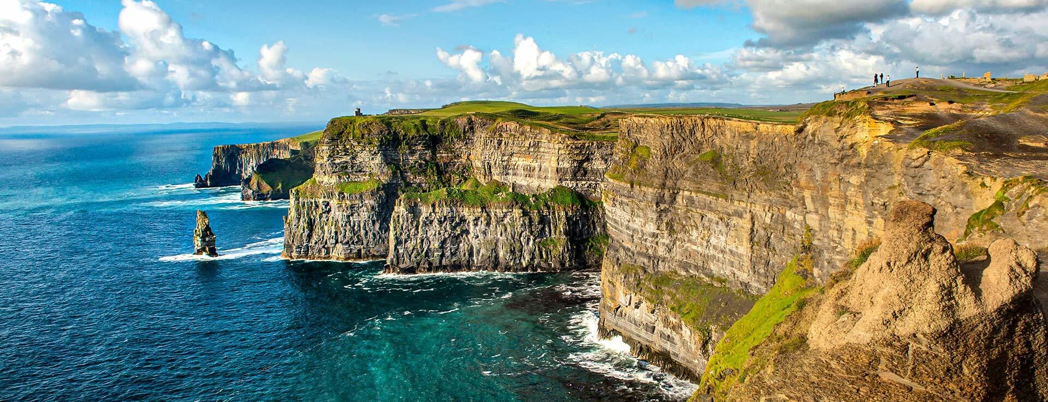

Visiting Dublin, Ireland in January 2026

Exploring Ireland is often described as stepping into a living postcard, where the landscape transitions seamlessly from the neon-green rolling pastures of the "Hidden Heartlands" to the jagged, salt-sprayed cliffs of the Wild Atlantic Way. To truly experience the island, one must embrace the "four seasons in one day" weather and the slow pace of its winding backroads. While iconic landmarks like the Cliffs of Moher and the Guinness Storehouse offer essential cultural touchstones, the magic of the Emerald Isle frequently reveals itself in the quiet intervals: a spontaneous "trad" music session in a Doolin pub, the mist clinging to the ruins of Glendalough, or the sight of sheep claiming right-of-way on a narrow coastal pass.

For those seeking to go beyond the typical tourist trail in 2026, the rugged Beara Peninsula and the soaring Slieve League cliffs in Donegal offer a dramatic, crowd-free alternative to the more famous Ring of Kerry. Whether you are hiking the ancient trails of the Wicklow Way or driving the serpentine bends of the Healy Pass, the journey is defined by a sense of deep history and the legendary "thousand welcomes" of the locals. From the medieval charm of Kilkenny to the bohemian energy of Galway, exploring Ireland is less about checking off a list of sights and more about finding a rhythm that matches the timeless, rugged beauty of the Atlantic coast.

September is arguably the "sweet spot" for a Celtic getaway. You’ll catch the tail end of the mild summer weather and the very beginning of the autumn colors, all while dodging the suffocating crowds of July and August. Our journey begins in Dublin, where the energy of Temple Bar and the history of Trinity College provide a lively introduction. After a day or two of urban exploration, most travelers head west toward the rugged Atlantic coast. September’s mist often clings to the Cliffs of Moher, making the dramatic drop into the ocean feel even more primordial. You’ll spend time in towns like Galway or Killarney, where the "trad" music sessions are moving from outdoor courtyards back into the cozy, peat-scented corners of local pubs. The landscape is lush, but you’ll notice the ferns and hillsides beginning to turn a rusty gold.

A short ferry transition brings you to Scotland, often landing in Glasgow or Edinburgh. Our home will be the cultural heart of Scotland, Glasgow, however Edinburgh is a short 45 min train right to the East. Glasgow is Scotland’s largest city and is often considered the "cool" sibling. It is a UNESCO City of Music with a legendary nightlife scene. Locals (Glaswegians) are famously friendly—the city's slogan is "People Make Glasgow"—and the vibe is much more down-to-earth and unpretentious. A modern city experience: incredible street art, a massive food scene, independent boutiques, and the best live music venues in the country.

Edinburgh will be catching its breath after the August festivals, making it the perfect time to walk the Royal Mile without shoulder-to-shoulder traffic. From there, the pull of the Highlands is irresistible. A drive toward the Isle of Skye or Glencoe reveals Scotland’s dramatic scale—towering peaks, deep lochs, and vast glens. In September, the purple heather is in full bloom across the moors, and the air has a crisp, bracing quality that makes a glass of single-malt whisky at a local distillery taste exactly as it should. The city is split into the Old Town (medieval, narrow closes, the Castle) and the New Town (grand Georgian terraces). It is visually stunning from almost every angle, with dramatic hills like Arthur’s Seat providing panoramic views.

Travel Details:
First things First!! Your tickets are e-tickets. Please check your itineraries when you get tickets. Carefully make sure that your proposed itinerary matches your flights. Also confirm your name, birthdate and other details match your passport and that your passport is not within 6 months of expiration. ONCE WE DEPART THE U.S. FOR EUROPE, THEY WILL BE DIFFICULT AND EXPENSIVE TO CORRECT!! BEST TO DO IT BEFORE WE LEAVE!

We are flying to Dublin. The baggage policy is the usual; one personal item (purse, briefcase, etc, one carry on; and one piece of luggage under 50 pounds is free. Additional bags will be charged at ~$100.00 per bag each way. Upon arrival at Dublin, we will be joined by our group participants departing from other cities. When you arrive, make sure to remain with your trip captain from your destination. (St Louis will be Peggy, and KC will be Me) we will coordinate a meeting location prior to heading to our transfer to our Hotel.

FLIGHT INFORMATION

The itinerary below is for the groups originating in Kansas City and St Louis.

MCI Origination: (Pending)

STL Origination: (Pending)

If you want, please call me and I will provide you with the Confirmation Numbers that you will need to check on the flights for exact departure times. Check with the gate agent on arrival to make sure of your fight number and departure gate.

On Arrival
When we arrive in Dublin we will be meeting up with a few travelers from other originations. When you arrive in Dublin, we will go through customs, retrieve our bags, and proceed from the baggage claim area to the main entry hall. Please wait near the exit from the baggage area until we locate our local ground transportation. We will have time for a bathroom stop and snacks before we head for the bus. Customs in Europe is a much less rigorous procedure than the one you will find in the U.S. There are about eight people who have not been with us before. Just stay close to someone in the group who will help you out with any questions or concerns.

Once the bus is loaded, we will head to our hotel, the trip should take about 45 mins depending on traffic. Word of advice here - use the facilities in the airport before getting on the bus!! After our stay in Dublin, we will travel by bus, and ferry, to Glasgow for our four-night visit there. For those of you not staying for the extension, we will help you with arrangements to get back to the Dublin Airport for your flights home.

Body Clock Warning!! We arrive in Dublin on Saturday morning, but it is only about midnight at home! When we finally do arrive at the hotel, you will certainly be dragging as you will have been awake for over 22 hours! The usual advice - try to sleep on the planes and on the bus ride to hotel. We will be arriving there around 5:00 P.M. If it is not too late, I would suggest that after you eat, take a walk around a bit to familiarize yourself with the town. Our hotel is just a short two-minute walk to the heart of the Temple Bar area.

For those of you traveling with us for the first time, please follow this advice. When you arrive, your first inclination will be to hop into bed, but don’t do it!! If you do, you will probably be there for the evening and wake up in the middle of the night, continuing on U.S. time and up for the remainder of the night! Another tip - for the week preceding our departure, try to go to bed about one hour earlier each night. This will help you to gradually move to European time. If you follow this advice, you will be quickly transferring to a European body clock!

WHEN RETURNING HOME, REGARDLESS OF THE DATE, CHECK YOUR BAGGAGE ALL THE WAY THROUGH TO YOUR FINAL DESTINATION !! Most of you will retrieve your bags at customs in you port of entry in the US, usually Chicago, Atlanta, or other major hubs we fly through. If, you are then continuing home on another flight, you can then re-check them to Los Angeles, St Louis, or wherever your destination may be.

For those staying over in Scotland, try to put ONLY those items you will need for your stay there in one bag and put the rest in other bags that can be stored in the Hotel baggage room. That will make your hotel room much larger and far less cluttered. Upon arrival at the hotel in Glasgow, we will try to arrange a storage space there so you can store your luggage that you do not plan to use. Once again, PLEASE USE THE LUGGAGE TAGS WE HAVE PROVIDED FOR YOU!!! It helps identify our group luggage, for both us and the baggage handlers. Let me know if you do not receive the tags, or if the name or address is incorrect. Finally, if possible, pack all the items you may need in your carry-on in case bags are delayed. You will appreciate having your necessities and some clothes to use until your bags are delivered to the hotel.

WEATHER AND DRESS

Early September is arguably the "sweet spot" for visiting both Ireland and Scotland. As the peak summer crowds thin out, you’re left with a landscape that is still vibrantly green but just beginning to hint at autumnal golds. The weather is generally mild and settled, often referred to as a "second summer" or an Indian Summer if you're lucky. In both countries, daily highs typically hover between 55°F–63°F, though it’s not unusual for a sunny afternoon to feel significantly warmer, especially in more sheltered inland areas.

However, "settled" is a relative term in this part of the world. You should expect the classic Atlantic "four seasons in one day" experience: one hour might bring crisp, brilliant sunshine, while the next brings a sudden, misty drizzle or a brisk wind off the coast. Scotland’s Highlands can feel a bit sharper and cooler than the Irish lowlands, particularly as the sun begins to set earlier. Rainfall is moderate—not as heavy as the late autumn deluges, but frequent enough that a high-quality waterproof jacket is non-negotiable.

DUBLIN
We’ll be using Dublin as our homebase for touring Ireland. While in Dublin we will be staying in the famed Temple Bar area at the Temple Bar Inn. Visiting Dublin feels like stepping into a living, breathing storybook where medieval history and modern energy collide. Whether you are wandering through the cobblestone paths of Temple Bar or marveling at the 18th-century Georgian townhouses surrounding Merrion Square, the city’s compact size makes it remarkably easy to explore on foot. Beyond the architecture, there is an undeniable warmth to the "Dub" personality—a blend of sharp wit and genuine hospitality that makes even a solo traveler feel like a local by the time they finish their first pint. No visit is complete without a stop at Trinity College to see the Book of Kells, an intricately illuminated manuscript from the 9th century. Just a short walk away, you can find the Guinness Storehouse, which offers a deep dive into Ireland’s most famous export, ending with panoramic views of the city from the Gravity Bar. For those who prefer a quieter side of history, Kilmainham Gaol provides a hauntingly beautiful look into Ireland’s struggle for independence, while the Little Museum of Dublin offers a quirky, community-led history of the city's people.

Things to do in Dublin:
1. Trinity College & The Book of Kells - Ireland’s oldest university is home to the Old Library and the world-famous Book of Kells, an intricately decorated 9th-century manuscript. Even if you aren't a bibliophile, the "Long Room" library looks like something straight out of a fantasy film. Pro Tip: Book well in advance; tickets sell out quickly.
2. Guinness Storehouse - It’s the most-visited attraction in Ireland for a reason. This seven-story immersive experience tells the story of the "Black Stuff." The highlight is the Gravity Bar at the top, which offers 360-degree views of the city along with a complimentary pint.
3. Kilmainham Gaol - This former prison is a hauntingly powerful monument to Irish history. It held many of the most famous political and military leaders in the struggle for independence. The guided tours are incredibly moving and offer deep insight into the nation's identity.
4. EPIC The Irish Emigration Museum - Located in the Docklands, this high-tech, interactive museum tells the story of the 10 million people who left Ireland and how they changed the world. It’s consistently voted Europe’s leading tourist attraction.
5. Phoenix Park & Dublin Zoo - As one of the largest enclosed city parks in Europe, Phoenix Park is massive. You can spot the resident wild deer herd, visit the Aras an Uachtaráin (the President's house), or spend the afternoon at the world-class Dublin Zoo.
6. St. Patrick’s and Christ Church Cathedrals - Dublin is unique for having two medieval cathedrals. St. Patrick’s (built in 1191) is the national cathedral, while Christ Church (founded in 1030) features a fascinating medieval crypt and the mummified "cat and the rat."
7. Dublin Castle - For over 700 years, this was the seat of British power in Ireland. Today, you can tour the State Apartments and visit the Chester Beatty Library on the grounds, which houses a world-renowned collection of rare manuscripts and art.
8. Little Museum of Dublin - If you want to understand the "real" Dublin, this is the place. It’s a quirky, people-focused museum filled with items donated by locals. Their 29-minute guided tours are famous for being fast-paced and very funny.
9. Grafton Street & St. Stephen’s Green - Walk down Grafton Street to hear some of the world’s best buskers (musicians often get discovered here). At the top of the street, you’ll find St. Stephen’s Green, a Victorian park perfect for a quiet stroll or a picnic.
10. Howth Cliff Walk - Take a 25-minute DART (train) ride north to the fishing village of Howth. The cliff walk offers stunning views of the Irish Sea. Afterward, reward yourself with fresh seafood or fish and chips along the pier.

Honorable Mention: Temple Bar It's the most famous neighborhood for a reason—the cobblestones and flower-covered pubs are beautiful. However, it can be very touristy and pricey. Local advice: Walk through it for the photos, but head to the Liberties or Stoneybatter for a more authentic (and cheaper) pub experience.

Daytrip Ideas:

The DART (Dublin Area Rapid Transit) runs along the coast and is the easiest way to see beautiful scenery without a car.
- Howth (Northbound): A charming fishing village. Walk the Howth Cliff Path for stunning views of the lighthouse, then grab fresh fish and chips at the harbor. Watch for seals in the marina!
- Dalkey & Killiney (Southbound): Often called Ireland’s "Bay of Naples." Hike Killiney Hill for panoramic views, then wander through Dalkey village—keep an eye out for locals like Bono or Enya.
- Malahide: Visit the beautifully preserved Malahide Castle and Gardens, then stroll down to the marina and beach.

Rail Maps: https://www.irishrail.ie/en-ie/travel-information/station-and-route-maps

Glendalough & Wicklow Mountains: Known as the "Garden of Ireland." Explore a 6th-century monastic settlement with a famous round tower, then hike around the Upper Lake. Pro Tip: Many bus tours combine this with a stop at Kilkenny, a medieval city with a massive castle.

Newgrange (Brú na Bóinne): This UNESCO World Heritage site is a Neolithic passage tomb older than both Stonehenge and the Egyptian pyramids. It’s an absolute must for history buffs.

Trim Castle: If you’ve seen the movie Braveheart, you’ll recognize this. It’s the largest Anglo-Norman castle in Ireland and sits in the historic Boyne Valley.

Big Hitter Tours from Dublin: These are long days (10–12 hours) but worth it if you only have one chance to see the iconic sights.
- The Cliffs of Moher & Galway: Cross the country to see the famous 700-foot cliffs. Most tours also give you a few hours to enjoy the colorful, busker-filled streets of Galway City.
- Giant’s Causeway & Belfast: Head north to see the unique hexagonal basalt columns in Northern Ireland. These tours often include a stop at the Titanic Belfast museum or the Dark Hedges (of Game of Thrones fame).

SCOTLAND
After seeing all Ireland offers we, we will travel by bus back to Belfast, Northern Ireland, and then take a ferry across to Cairnryan and then drive to our Hotel in Glasgow. This will take us approximately one hour and forty-five minutes.

Full itinerary for our transfer below Dublin to Glasgow Friday 11th September 2026
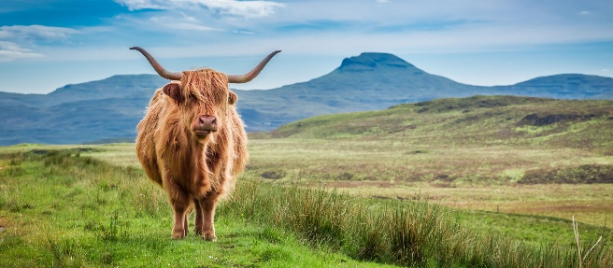
12.15 - Coach arrives in Dublin City
12.30 - Coach departs for Belfast Port
14.30 - Coach arrives Stena Line Terminal, Belfast
14.45 - Express Coach onboard Ferry
15.30 - Sail
17.50 - Dock Cairnryan
20.00 - Coach arrives Buchanan Bus Station, Glasgow

Exploring Scotland is an invitation to step into a landscape where the modern world feels delightfully thin, giving way to ancient history and raw, elemental beauty. In the capital, Edinburgh, you can wander the cobblestoned Royal Mile, where medieval tenements lean over narrow "closes," or hike the remains of an extinct volcano at Arthur’s Seat for a panoramic view of the city’s iconic skyline. Beyond the urban centers, the Highlands offer a more visceral experience; driving through the hauntingly beautiful Glencoe or along the winding North Coast 500, you’ll encounter mist-covered glens, jagged peaks, and ruins like Urquhart Castle that stand as silent sentinels over the deep, dark waters of Loch Ness.

In 2026, the allure of Scotland extends further into its remote corners, as travelers increasingly seek out the "adventure luxe" of the Outer Hebrides or the Norse-influenced heritage of Shetland. On the Isle of Skye, the dramatic rock formations of the Old Man of Storr and the ethereal Fairy Pools offer a surreal backdrop for hikers, while the quiet fishing villages of the East Neuk of Fife provide a slower pace centered on world-class seafood and coastal charm. Whether you’re "set-jetting" to find filming locations from Outlander, Star Wars or seeking the "water wellness" of a remote sea loch, Scotland remains a place where the spirit of the land—rugged, feisty, and deeply welcoming—makes every journey feel like a homecoming.

GLASGOW
While in Glasgow we will be staying at the Motel One Glasgow. This hotel is centrally located and is less than a block from the train station. Glasgow is a vibrant city known for its rich industrial history, stunning Victorian architecture, and world-class museums. From historic cathedrals to modern riverside galleries, the city offers a diverse range of attractions.

- Kelvingrove Art Gallery and Museum - A stunning red sandstone masterpiece of Spanish Baroque architecture. It houses everything from medieval armor to Salvador Dalí’s Christ of Saint John of the Cross. Don't miss: The daily organ recitals at 1 PM (Sundays at 3 PM) in the grand central hall.
- Glasgow Cathedral & The Necropolis - The Cathedral is the oldest building in Glasgow (12th century) and one of the few to survive the Reformation intact. Just behind it, climb the hill to the Necropolis, a Victorian "City of the Dead" inspired by Père-Lachaise in Paris. Top Tip: The summit of the Necropolis offers one of the best panoramic views of the city skyline.
- Riverside Museum & The Tall Ship - Designed by the late Zaha Hadid, this hyper-modern building houses the city’s transport museum. Outside, you can board the Glenlee, a restored 19th-century sailing ship docked on the River Clyde.
- University of Glasgow & The Hunterian - The university’s Gothic cloisters are a favorite for photographers (and Outlander fans). While there, visit The Hunterian, Scotland’s oldest public museum, which features Roman artifacts from the Antonine Wall.
- George Square & City Chambers - The civic heart of the city, surrounded by statues of famous Scots like Robert Burns. The City Chambers offers free guided tours twice a day, revealing an interior with more marble than the Vatican.
- Glasgow Botanic Gardens & Kibble Palace - Located in the trendy West End, this park features the Kibble Palace, a magnificent 19th-century glasshouse filled with tropical ferns and marble statues. It’s the perfect escape on a "dreich" (dreary) day.
- Pollok Country Park & The Burrell Collection - Glasgow’s largest park is home to a herd of Highland cattle and the Burrell Collection, a world-class art museum that reopened recently after a major refurbishment.
- Duke of Wellington Statue (with the Cone) - Located outside the Gallery of Modern Art (GoMA), this statue of the Iron Duke is famous for the traffic cone permanently perched on his head—a symbol of the city’s irreverent sense of humor.
- The Glasgow Mural Trail - Glasgow’s walls are covered in massive, high-quality street art. You can follow a self-guided trail through the city center to see murals of local icons like Billy Connolly and the famous "St. Mungo" mural on High Street.
- Buchanan Street & Merchant City - For the "Style Mile" experience, walk down Buchanan Street for world-class shopping. Then, head east to Merchant City, a historic district of 18th-century tobacco merchant warehouses now filled with chic bars, galleries, and restaurants.

EDINBURGH
Edinburgh is a city defined by its dramatic skyline, blending medieval history in the Old Town with neoclassical elegance in the New Town. Its sights range from ancient fortresses and royal palaces to volcanic hills and subterranean alleys. Edinburgh is rick in sites and attractions I have create a top ten list below.

- Edinburgh Castle - The crown jewel of the skyline, this historic fortress sits atop Castle Rock, a dormant volcano. It houses the Honours of Scotland (the oldest Crown Jewels in Britain) and the Stone of Destiny. Pro Tip: Arrive by 1:00 PM (except Sundays) to see the firing of the One O'Clock Gun.
- The Royal Mile - This famous stretch of cobblestone connects the Castle to the Palace of Holyroodhouse. It’s the heart of the Old Town, packed with "closes" (narrow alleyways), street performers, and historic landmarks like St. Giles' Cathedral.
- Arthur’s Seat - For the best panoramic views of the city and the sea, hike up this ancient volcano in Holyrood Park. It’s a bit of a trek, but the 360-degree vista at the top is unbeatable.
- Palace of Holyroodhouse - The King’s official residence in Edinburgh. You can tour the State Apartments and see the historic rooms of Mary, Queen of Scots, including the spot where her secretary, David Rizzio, was famously murdered.
- National Museum of Scotland - A stunning mix of Victorian and modern architecture. It’s free to enter and houses everything from Dolly the Sheep (the first cloned mammal) to giant T-Rex skeletons and ancient Scottish artifacts.
- Calton Hill - If you want the "postcard shot" of Edinburgh without the intense hike of Arthur’s Seat, this is the place. It’s home to the National Monument (Scotland’s "unfinished Parthenon") and the Dugald Stewart Monument.
- Victoria Street & Grassmarket - Victoria Street is a colorful, curving road that many believe inspired Diagon Alley. It leads down to the Grassmarket, a historic square now filled with lively pubs and a dark history of public executions.
- The Real Mary King’s Close - Step beneath the Royal Mile into a preserved 17th-century street. This underground tour reveals how people lived—and died during the plague—in the city's hidden subterranean world.
- Dean Village - A hidden oasis just a short walk from the city center. This former grain milling village looks like a fairytale, with 19th-century buildings nestled along the Water of Leith.
- The Royal Yacht Britannia - Permanently docked in Leith, this was the floating residence of Queen Elizabeth II for over 40 years. You can tour five decks, from the gleaming engine room to the surprisingly modest royal bedrooms.

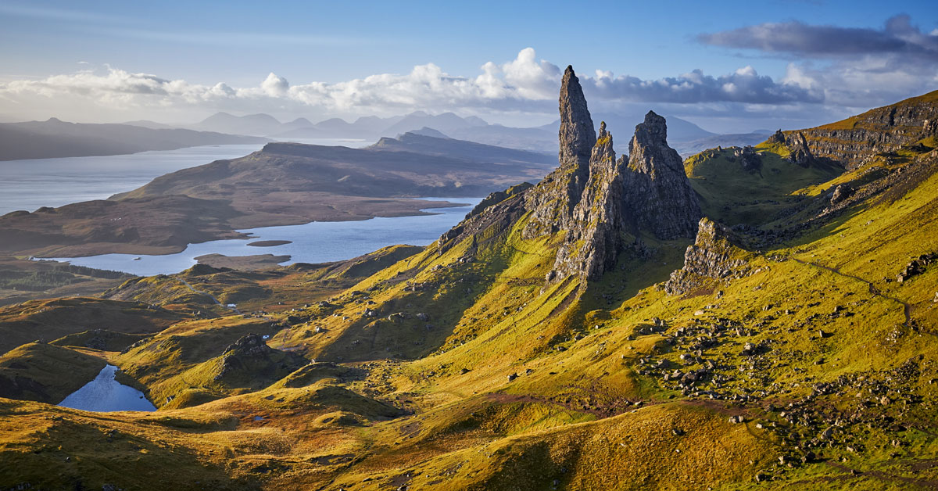

Daytrips Ideas:
Natural & Scenic Escapes
Loch Lomond & The Trossachs - Classic Scottish scenery with mountains, lochs, forests, and hiking trails.
Visit Balloch village at the southern tip and enjoy lakeside walks, cruises, or a picnic.
West Highland Line Scenic Ride - One of the most beautiful rail journeys in the world — you can disembark at scenic spots like Arrochar, Garelochhead, or go further to Oban.
Ayrshire Coast & Beaches - Head to Ayr for seaside walks, beaches, and ice cream, or continue to Largs for coastal trails and cafés.
Isle of Arran - Known as “Scotland in miniature” — mix of mountains, coastal views, and Brodick Castle & Country Park. Easily reached by train + ferry.

History & Culture
Stirling - Historic city with Stirling Castle and the Wallace Monument — rich Scottish heritage and commanding views.
New Lanark World Heritage Site - 18th-century cotton mill village with restored buildings, museum exhibits and river walks — great for history fans.
Falkirk Wheel & The Kelpies - The Falkirk Wheel is an astonishing rotating boat lift; nearby are the giant Kelpies sculptures and parklands.
Paisley - Charming historic town with Paisley Abbey, great architecture and cafés — a quieter alternative for a half-day.
Auchentoshan Distillery - Whiskey lovers can tour a classic Lowland distillery on the banks of the Clyde

Important Links:
YouTube Playlist for the trip
Gateway Ski Club Website
Gateway Ski Facebook Group
Temple Bar Inn
Motel One Glasgow

Your cost for the trip to Ireland and Dublin:
$ 3280.00 for the 7 days in Dublin 3 in Scotland.

You will receive:
Round Trip Air from Kansas City or St Louis
- Transfer from Dublin Airport to the Temple Bar Inn.
- Seven Nights lodging in a picturesque Temple Bar area of Dublin.
- Full English breakfast each day.
- Transfer to Glasgow via private coach and ferry.
- Happy hour welcome drink upon arrival.

Sample Itinerary

Date | City | Country | Activities
9/4/2026 |  | Ireland | Travel Day
9/5/2026 | Dublin | Ireland | Dublin tour, or perhaps a trip to Kilkenny, or Cork
9/6/2026 | Dublin | Ireland | Dublin tour, Guinness & Jameson, Book of Kells, Trinity, Dublin Castle
9/7/2026 | Dublin | Ireland | Dublin to Belfast Black Cab, Dunluce Castle and Giant's Causeway
9/8/2026 | Dublin | Ireland | Cliffs of Moher, Burren and Galway Day Tour from Dublin
9/9/2026 | Dublin | Ireland | Dublin to Glendalough, Wicklow and Kilkenny
9/10/2026 | Dublin/Glasgow | Scotland | Travel Day, Bus to Belfast and Ferry to Scotland. Evening Stroll and dinner in Glasgow
9/11/2026 | Glasgow | Scotland | Travel Day, Edinburgh Castle, Royal Mile walking tour Etc
9/12/2026 | Glasgow | Scotland | Loch Ness, Glencoe & The Highlands from Edinburgh
9/13/2026 | Glasgow | Scotland | Glenfinnan, Glencoe and Scottish Highlands Day Tour
9/14/2026 |  |  | Travel Day

TRAVEL TIPs

Traveling with our group.
We have a great group that enjoy the trip packages we put together but understand that this is not a guided tour. Our goal is to get the group to amazing destinations will little worry, once there you are free to explore on your own accord. This doesn’t mean that there will be no guided trips or the opportunity to combine our group purchases power to garner travel discounts or organize private tours. We do this for couple reasons we are on vacation too and secondly, we want to make sure that our group members have flexibility in customizing their own itineraries tailored to do and see what you like without being tied to a single group itinerary. I hope this works for all and I’m certain you will enjoy all that we do put together.

Passport and Plane Tickets
If you don't have a passport, you can't go. Also make sure that your passport will not expire within 6 months of the return as this can be problematic. In addition, be sure to take it with you whenever you may possibly be crossing a border. We have had situations occur which underscores the importance of having your passport with you! Rarely are you asked to show one, but if you don't have it, you could be in for long delays and hassles. You should make two photocopies of your passport. Leave one at home to be faxed in the event you lose or get caught without your passport. Put the other in your wallet or someplace other than where you keep your actual passport while on the trip. Once again, know where it is always. There are testimonies!! This is once when being paranoid is a good thing!

Your tickets are “E tickets” . I will get the “receipts” about 30 days prior to departure and will get them out to you. You will be able to go to the airport and print them out at your city of departure. FINAL WORD OF WARNING ABOUT YOUR TICKETS: Check them when you receive them and make CERTAIN that the times, dates and flight numbers match your itinerary. If they do not, check with me immediately. Don’t wait until the middle of the week in Zermatt to make this discovery and tell me. It will probably be too late, and I won’t be able to do anything about it at that time. It could be very costly!!! They can be easily changed BEFORE we leave, but will be difficult, if not impossible, to change once we are in Europe!

Currency
The currency unit in Ireland is the Euro, in Scotland it is the British pound sterling. Currently, the exchange rates are currently $1.12 and $1.39 to the USD as of Feb 11, 2026. Currently, the Euro is trading about $1.12. As a quick exchange tool, just figure that if something costs 10 Euros, it is going to cost you about $11.20. The Pound is currently trading at $1.39, so you are paying a 39% increase on goods. It is suggested that you shop around for a good exchange rate, and preferably at a bank as opposed to an exchange house. I would avoid going to any bank in the states to get Euros. You will not get a good deal. When you get to Dublin, just go to an ATM and get Euros. Please make sure your bank knows you are travelling. Every year someone’s bank has a fraud alert and cards are temporarily shut off. Seems to occur more often at smaller banks and Credit Unions. You also need to inquire as to fees, etc. for using the cards as well as any intricacies about ATM usage. That is your best exchange rate because they change millions of dollars, and any fees are minimal. Also, some credit cards have no transaction fees! By using your cards, you will get the best exchange rate as it exists at that time.

Cellular devices and Data
Call your providers prior to traveling and add the “international day pass” this will allow your device to work as it does here in the US. They will likely charge you a fee each day you use it, but it’s often worth the convenience for $10 a day. I treat it as a sunk cost of $130.00 and call it good. This is much better than getting home and having a bill for $800.00 for not calling ahead of time.

Baggage
Your first checked bag is free. Check the Airlines baggage policy as they change often. Historically, you will get one checked back up to 50 LBs and one care on suitcase, and a personal item. Fees may occur if you have more.

WHEN YOU CHECK IN AT YOUR DEPARTURE AIRPORT BE SURE YOU CHECK YOUR BAGGAGE ALL THE WAY THROUGH GENEVA! Once they have been checked at the originating airport, hopefully you will not see them again until arrival at the Dublin airport. In Dublin you will then take them through customs and put them on the bus. Remember, YOU ARE YOUR OWN PORTER! If a situation does arise where you will have to be “luggin’ luggage”, keep in mind that you will be the “lugger”. :-D. In addition, put an identification tag and or a copy of your passport inside your checked bags. If the tags are torn off during transport, you will have identification in the bag. This may become important. I strongly advise, if you are on your first European Trip, to talk to someone about what you really need to pack. You can get by on a great deal less than you think. Also, if you have any questions about baggage, check the Airline web site for weight and size restrictions.

Electrical
Europe uses a 240V power system so you will need type G power adapters for your devices. Good news most PCs, Tablets and Phones are capable of being plugged into 240V. Most hair products are not, make sure you have the right hairdryer or flatiron before plugging it in. If not it will be your last use of it, make sure it is switchable and that you have flipped the switch prior to plugging it in. Suggest you buy something like the following: https://a.co/d/bbibCcL

Bath items
Hair dryers in Europe are usually weak, if your hair needs to be blown out, pack your own tools.
Towels and hand towels are abundant and there are towel heaters in most rooms. However, most hotels will not have wash clothes so for this I suggest bringing your own set or travel Loofahs..

Suggested Deposit Schedule
Feb 1st - $ 500
May 1st - $ 1000
July. 1st - $1000
Aug. 1st – Final payment.
Cancellation policy is very restrictive after June 1st, and refunds will be limited.

Payments
You have a few payment options. Pay by Check by Mail:
62 Huntington Parkway
St. Charles, Mo 63301

Or you can Venmo to Bill and he can transfer it to the bank.


I know that there are many other questions that you now have or will come up. Hopefully, this will answer some of them. Please feel free to call either me (816-777-6794) or email at bjjones133@gmail.com for any other information.

WELCOME ABOARD!!

